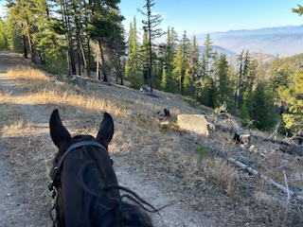
Ride the Loup
Equine Distance Riding Association Endorsed & PNER Recognized Ride

September 19, 2026
Intro Trail Ride 25 Mile Ride 50 Mile Ride
$75 $150 $150
Ride fees will increase by $20 if registering after September 12, 2026.
Youth riders 17 and under are FREE. Ride managers pay ½ price and EDRA doesn’t charge nonmember fees.
*All distances add $15 per night camping fee per vehicle, zero trace camping, NO FIRES
*Certified Weed Free Hay is required
*Helmets required for all riders at all times when mounted
*All dogs must be leashed
Location/Directions: Ride the Loup is located at the Loup Loup Pass ski area on HW 20 between Twisp and Okanogan. Trails are typical mountain footing with single track and logging roads. Hoof protection is highly recommended.
From N or S take Highway 97 to the exit for Okanogan/Hwy20. Turn west, cross the river, turn left (south) on Highway20. Drive 18 miles on Highway 20 (up Loup Loup Pass), turn right onto North Summit (forest service #4200) then first left on to the ski hill road and follow signs to camp. From Twisp drive east on North Cascades Hwy 20 for 2 miles & turn left on WA- 20, drive 11 miles up Loup Loup Pass, turn left onto North Summit (forest service #4200) Road then take first left towards ski hill and follow signs to camp.
Head Vet: Kate Woodard DVM Treatment Vet: TBD
Contact Info:
Amy Jones: acenquist1980@gmail.com (360)610-1750
Laurissa Everett-Bulfin: mtnvequestrian@gmail.com (425)373-6997
Pre-Registration will be on www.equinedistanceriding.com

