Results of the Proposed Awards Revisions – 75 responded out of 237 sent!!! Amazing response. Not every award is represented here. I picked awards that I felt could better represent the current PNER membership. For example, no changes were recommended to the Overall Best Condition horse or the Top 3 State awards. Several reductions were opposed by the membership. Those awards will remain unchanged. I want to thank our new PNER President Darlene Merlich for creating the poll. I would never have figured out how to do it on my own. All changes to the award definitions will commence with the 2026 ride season. All changes are identified in the Awards Descriptions in the 2026 Handbook.
Thank you for taking the time to go through this poll.
Lois Fox, Awards Coordinator
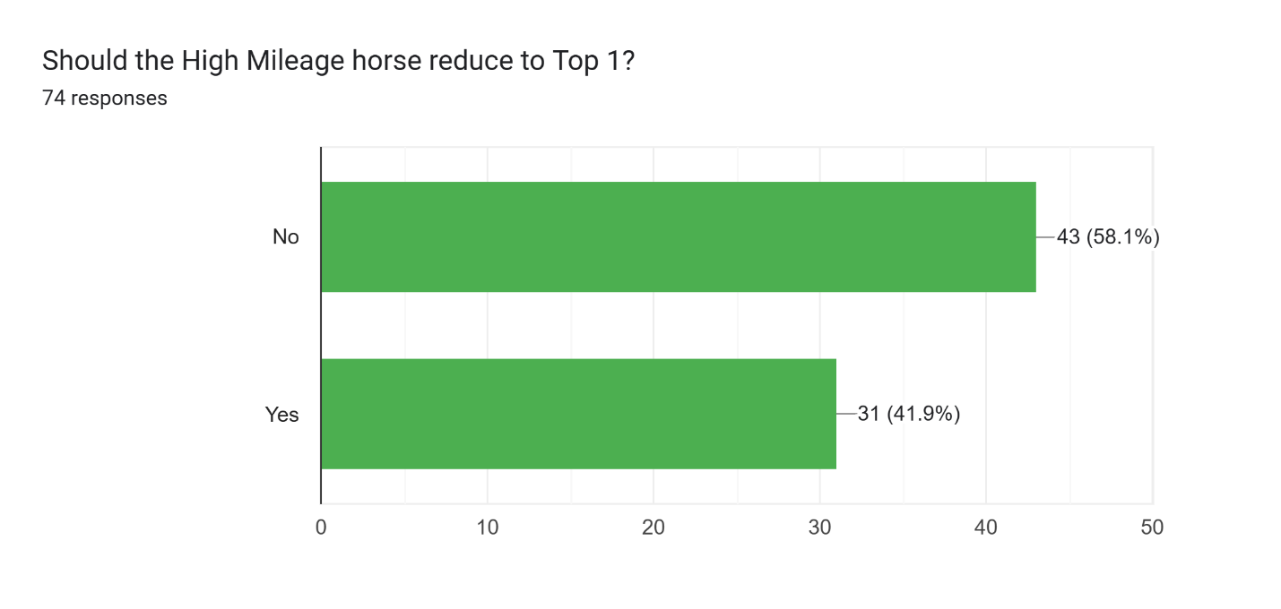
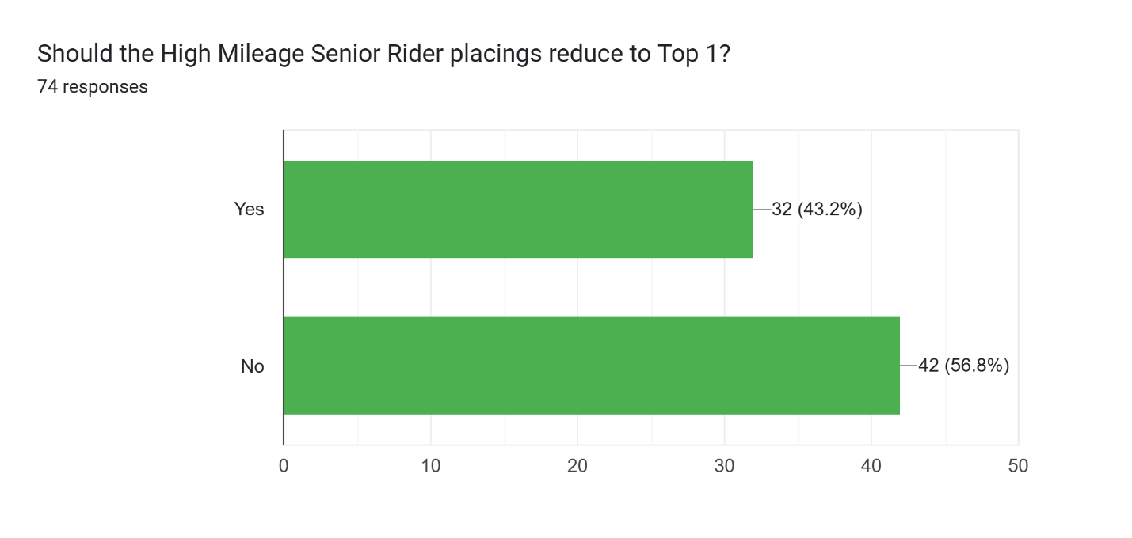
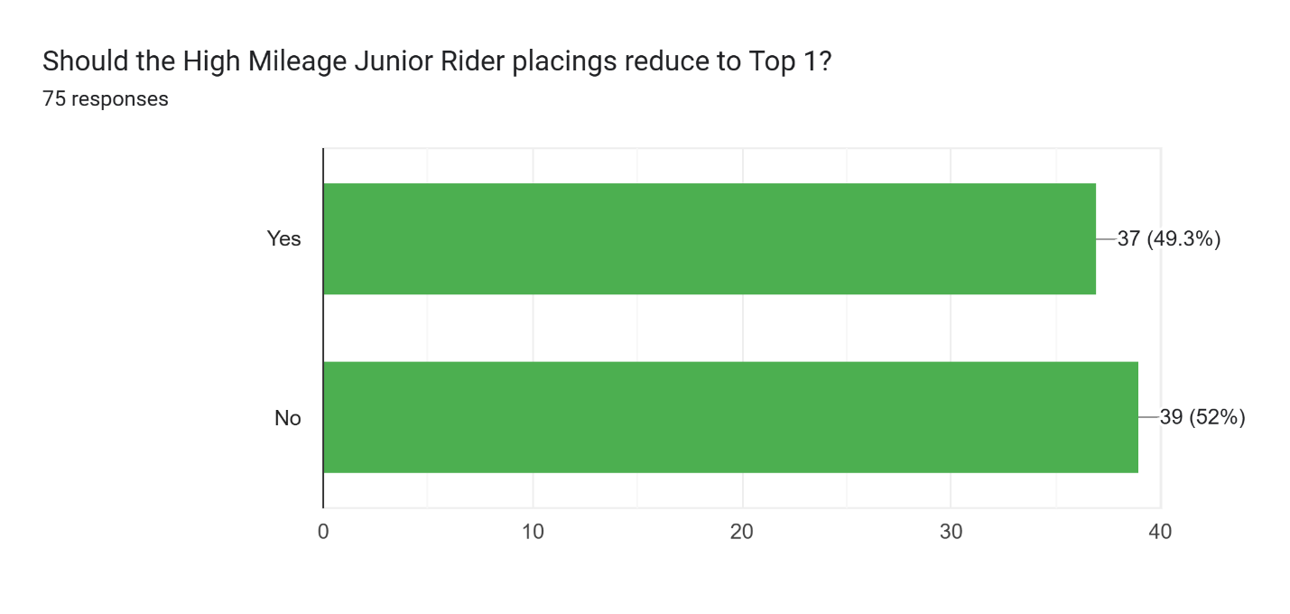
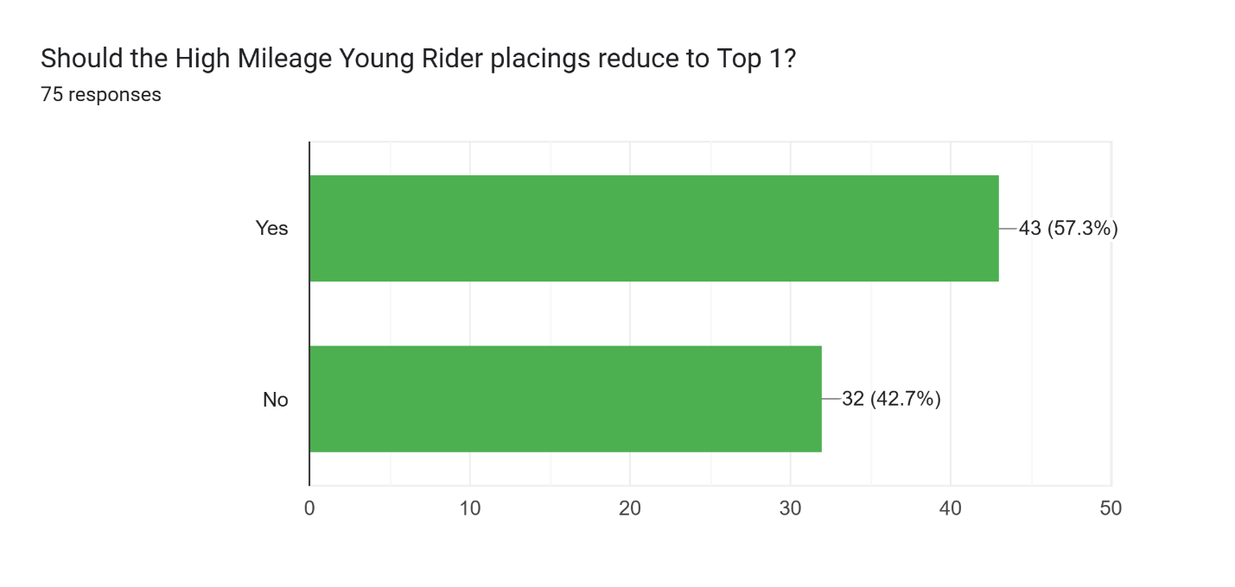
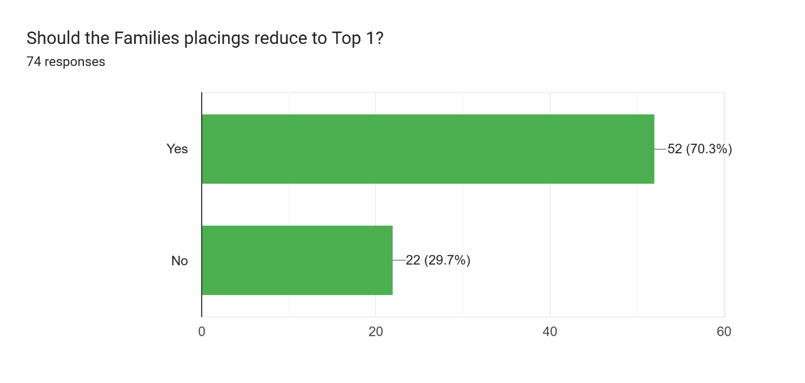
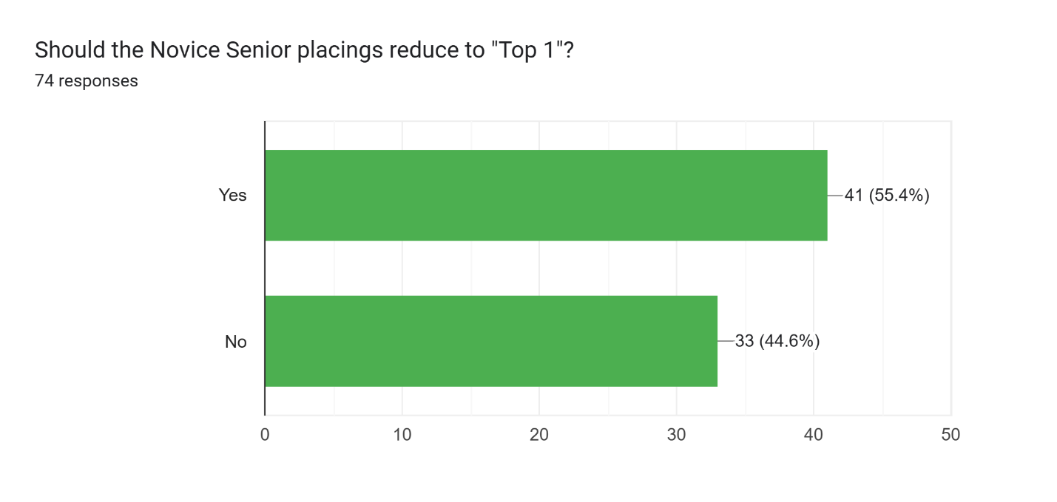
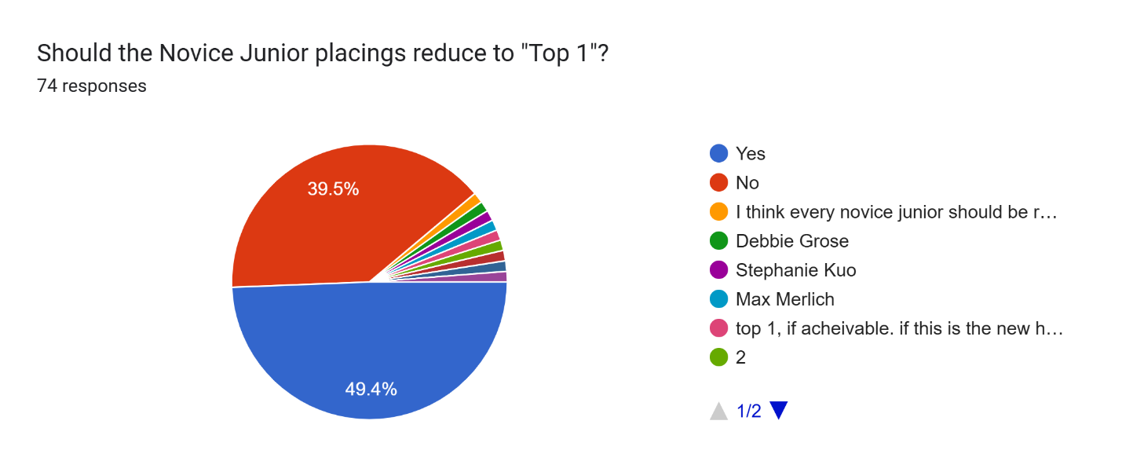
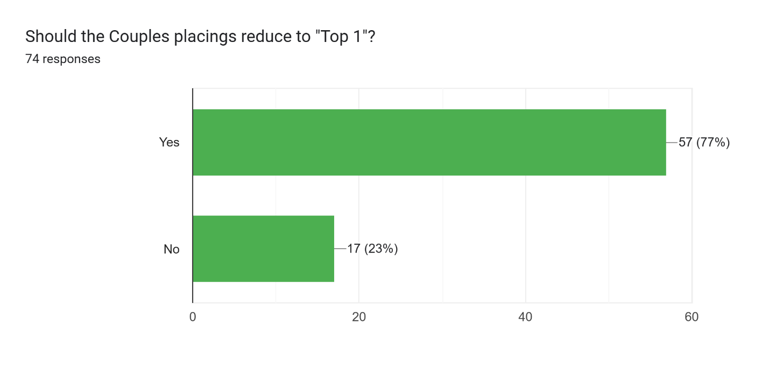
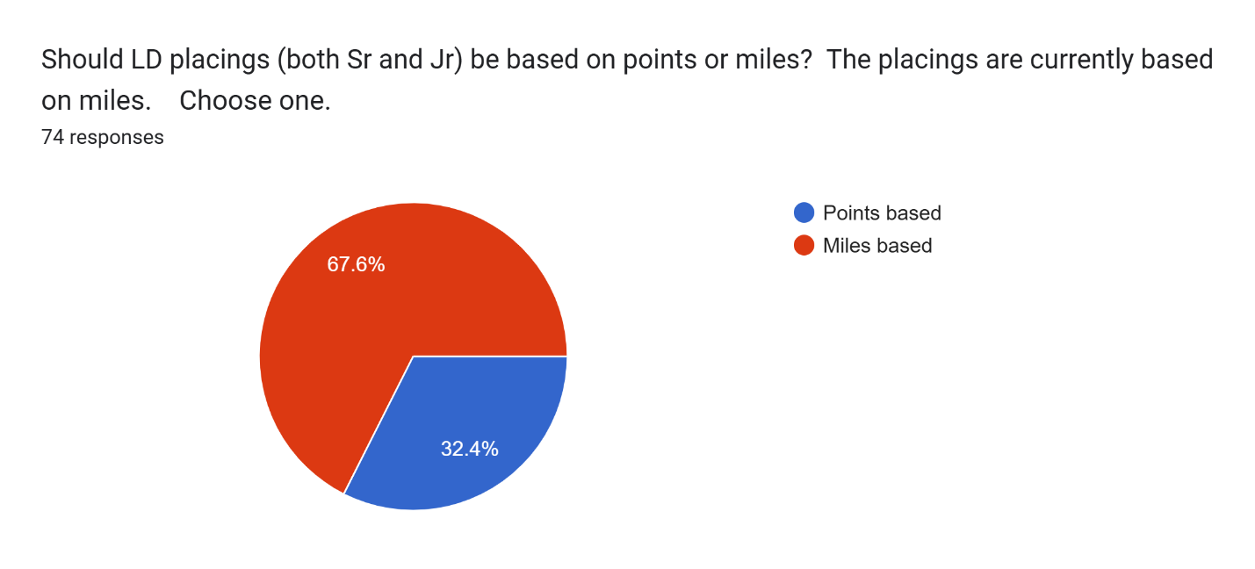 Sandybaar Note: I would like to suggest if they are separated, do it by consecutive miles, rather than number of completions. LD Sandybaar would be 10 consecutive completions <500 miles, Endurance Sandybaar is 10 consecutive completions >500 miles. That will allow for a combination of distances at least equaling 500 miles.
(The explanation wouldn’t completely copy below. Insert: mileage doubles to achieve 10 consecutive)
Choose one.
75 responses
