

Diamond in the Rough

(an EDRA endorsed ride)

June 27, 2026

LOCATION: Ride Camp is in Historic Downtown Roslyn, WA at the Roslyn Riders facility – 70 Martin Rd, Roslyn, WA – within walking distance to restaurants and where the 1990’s TV show, Northern Exposure was filmed. Golf, Swiftwater Cellars winery, museum, cafes, shops, fuel, and grocery are all close by.

DIRECTIONS TO RIDE CAMP: From Interstate 90 take Exit 80 towards Roslyn and Suncadia. Remain on Bullfrog Rd toward Roslyn / Suncadia. After passing Suncadia, at second round about, head North on SR903. Turn right onto Martin Rd, shortly after exiting the roundabout. Parking is in the big, flat field on the left side of Martin Rd. Registration and vetting will be on the right.

Stalled camping may be available at the Washington State Horse Park. Arrangements for securing a stall can be made online by visiting their website at https://www.wahorsepark.org/home

TRAIL: Single track, jeep roads, and logging roads. Good footing through the Teanaway Community Forest, Nature Conservancy, and private lands. Some rock, significant climbs, magnificent views, lots of grass and much more.

RIDE ENTRY FEES & DISCOUNTS:
- 50-mile and 25-mile Distance Rides – $150 Ride Entry Fee
- 10-mile Intro Ride – $75 Ride Entry Fee
- $20 Discount for EDRA members
- Participants in the 25-mile and 50-mile distances who are under age 18 will ride for FREE!

We are limited to 100 participants which will be based on a first-paid-first served basis. Online pre-registration is expected to be available in late April. A $20 late fee will be assessed on any registrations where payment is received after June 20, 2026.

PRELIMINARY SCHEDULE & INFORMATION: Although the full schedule is still under development, participants can expect ride camp to open on Thursday, June 25, registration check-in, pre-ride vetting and an educational clinic and pre-ride meetings for both experienced participants and an additional session for those new to the sport to be held on Friday, June 26.

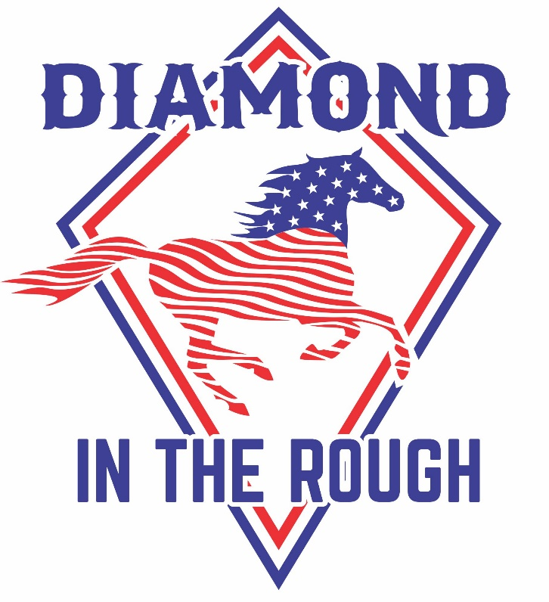
GENERAL: EDRA & PNER rules apply. Hoof protection is recommended. Helmets when mounted are required. Awards include completion, first place, top 10, BC and High Vet Score for 25-mile and 50-mile distances. Completion awards for Intro Ride.

VETERINARIANS: Kate Woodard, DVM – Head Vet, others will be named later

MORE INFORMATION: For updates, watch the Equine Distance Riding Association – Start Ready, Finish Proud website, as well as the ride’s website at https://renegaderendezvous.wixsite.com/diamond

QUESTIONS? CONTACT:
Kathleen Dunham Victoria Marsh
(253) 569-6575 (509) 460-0570
kdunham@wcflooring.com victoriamarsh1990@gmail.com

